Appendix C: IEEE 830 Template
Software Requirements Specification
for
Public Transport Tickets System

Version 6.0
Prepared by Jakub Boczkowski
Lodz University of Technology - WEEIA IFE
03.03.2026

Table of Contents
Revision History
Name | Date | Reason for Changes | Version
Jakub Boczkowski | 03.03.2026 | Initial version | 1.0
Jakub Boczkowski | 10.03.2026 | Added UML diagram | 2.0
Jakub Boczkowski | 17.03.2026 | Added Class diagram | 3.0
Jakub Boczkowski | 24.03.2026 | Added sequence / state /activity diagrams | 4.0
Jakub Boczkowski | 14.04.2026 | Created GitHub repository | 5.0
Jakub Boczkowski | 24.04.2026 | Finished all remaining points | 6.0
1. Introduction
1.1. Purpose
The purpose of this product is to provide users with mobile application which will decrease the time they spend on purchasing public transport tickets. The current version is 1.0. It aims to enable them to purchase tickets by clicking only one button while entering chosen way of transport and then clicking it again while leaving. The project shall automatically get users location and find appropriate stop.
1.2. Document Conventions
The document follows a standard typographical convention. Detailed requirements are highlighted when there is a special significance.
1.3. Intended Audience and Reading Suggestions
This document is intended for specified audience, including Developers, Users, Testers and Marketing Staff.
They are all to inform other readers of the steps taken for further development. There is a special sequence for reading the document for each members of the audience mentioned above:
Developers: Should focus primarily on Section 4 (External Interface Requirements), Section 5 (System Features), and Sections 8-9 (UML Diagrams) to understand the technical architecture, class structures, and behavioral logic required for implementation.
Users: Should review Section 2 (Overall Description) and Section 3 (System Features) to gain a high-level understanding of what the application does and how it simplifies the commuting process.
Testers: Should concentrate on Section 5 (System Features/Modules) and Section 6 (Nonfunctional Requirements) to design appropriate test cases, ensuring all functional and performance constraints are met.
Marketing Staff: Should focus on Section 1 (Introduction) and Section 2 (Overall Description) to understand the product's business value, target audience, and primary benefits for promotional campaigns.
1.4. Product Scope
The Public Transport Tickets System is a mobile application designed to completely automate and simplify the process of purchasing public transport tickets. Its primary goal is to eliminate the need for physical ticket machines and complex manual ticket selection in existing apps. By utilizing GPS technology, the software will allow users to seamlessly check in and check out of a vehicle with a single button press, while the system calculates the correct fare based on the traveled distance or time. This aligns with the modern objective of making public commuting faster, more accessible, and user-friendly.

1.5. References
- IEEE Std 830-1998, IEEE Recommended Practice for Software Requirements Specifications.
- "Lab 1: Requirements Analysis" presentation, dr inż. Abdulla Juwaied, Lodz University of Technology - IFE

2. Overall Description
2.1. Product Perspective
The Public Transport Tickets System is a new, self-contained mobile application. It is not a direct follow-on to an existing software family, but rather an innovative alternative to traditional, manual ticket-purchasing apps currently used in public transport.
2.2. Product Features
- One-click check-in and check-out process.
- Automatic user geolocation to identify the starting and ending stops.
- Automated fare calculation based on the registered route.
- Digital ticket generation and display for inspection purposes

2.3. User Classes and Characteristics
Passengers (Primary Users): Everyday commuters and tourists. They require a highly intuitive, fast, and simple interface without the need for high technical expertise. This is the most important user class.
Ticket Inspectors: Transport authority staff who will need a reliable way to visually or digitally verify the generated active tickets.

2.4. Operating Environment

The software will operate as a mobile application on modern smartphones running Android and iOS operating systems. It requires continuous access to the device's GPS module and an active internet connection to communicate with the main server.

2.5. Design and Implementation Constraints

At this stage, the main constraint is the reliance on the accuracy of the mobile device's GPS signal, which can be limited inside specific vehicles (e.g., underground trams). Additionally, the system must not drain the smartphone's battery excessively while tracking the location during the ride. We are not specifying backend databases or programming languages yet, to avoid implementation bias.

2.6. User Documentation
The application will include a short, interactive "first-launch" tutorial showing the one-click process. A built-in "Help & FAQ" section will also be provided.

2.7. Assumptions and Dependencies
It is assumed that the user will grant the application permission to access their location services. The project depends on external map and geolocation APIs (e.g., Google Maps API or equivalent) to accurately match coordinates with public transport stops.
3. System Features
3.1. One-Click Check-In and Check-Out
This feature allows users to initiate their journey by clicking a single button when entering the transport vehicle. The user completes the journey by clicking the same button upon exiting. This significantly decreases the time users spend purchasing tickets.
3.2. Automatic Stop Identification
The system automatically retrieves the user's current geographical location. Using this data, it finds the appropriate public transport stop where the user is beginning or ending their journey.
3.3. Automated Fare Calculation
Based on the identified check-in and check-out stops, the application automatically calculates the correct fare for the journey. This eliminates the need for manual ticket selection, zones, or time limits by the user.
3.4. Digital Ticket Display
Upon a successful check-in, the system generates an active digital ticket. This screen acts as proof of purchase and can be displayed to ticket inspectors during the ride.
4. External Interface Requirements
4.1. User Interfaces Overview
The application will feature a minimalist, mobile-first Graphical User Interface (GUI). The main screen will be dominated by a single, large action button that toggles between "Check In" and "Check Out" depending on the journey state. A secondary map view will visually confirm the user's current GPS location and matched transport stop. When checked in, a persistent bottom sheet or separate tab will display the "Active Ticket" containing a dynamic QR code and timer. The interface will adhere to standard Material Design (Android) and Human Interface Guidelines (iOS) for intuitive navigation and error handling (e.g., pop-up alerts if GPS is disabled).
4.2. Hardware Interfaces
The software requires interaction with the mobile device's built-in GPS/GLONASS module to accurately retrieve geographical coordinates. It also relies on the device's touchscreen for user inputs and the cellular/Wi-Fi network antenna to transmit location and ticketing data to the central server in real-time.
4.3. Software Interfaces
Geolocation API (e.g., Google Maps API / OpenStreetMap): The system will send raw GPS coordinates to this API and receive the closest matching public transport stop data.
Payment Gateway API (e.g., Stripe, PayPal, or Bank API): Used to securely process the calculated fare at the end of the journey. The system will send the fare amount and user token, receiving a payment success/failure confirmation.
Central Ticket Database: The mobile app will communicate via RESTful API over HTTPS with the backend server to log journeys, synchronize ticket status, and allow Ticket Inspectors to verify active tickets.
5. System Features/Modules
5.1. One-Click Check-In and Check-Out
5.1.1 Description and Priority
This is the core functionality allowing users to start and end their journey using a single button.
Priority: High.
5.1.2 Stimulus/Response Sequences
- Stimulus: The user presses the "Check In" button.
- Response: The system fetches the current location, generates an active ticket, and updates the UI.
- Stimulus: The user presses the "Check Out" button.
- Response: The system fetches the end location, finalizes the journey, and triggers the fare calculation.
5.1.3 Functional Requirements
- REQ-1.1: Upon clicking "Check In", the system shall request and record the user's current GPS coordinates.
- REQ-1.2: Upon a successful check-in, the system shall instantiate a new Ticket object with isActive set to true.
- REQ-1.3: Upon clicking "Check Out", the system shall record the final GPS coordinates and change the Ticketstatus to inactive.
5.2. Automated Fare Calculation
5.2.1 Description and Priority
The system automatically calculates the cost of the journey based on the distance between the check-in and check-out stops.
Priority: High.
5.2.2 Stimulus/Response Sequences
- Stimulus: The check-out process is successfully completed.
- Response: The system computes the distance and deducts the appropriate amount from the user's payment method.
5.2.3 Functional Requirements
- REQ-2.1: Upon check-out, the system shall calculate the geographical distance between the starting Stop and ending Stop.
- REQ-2.2: The system shall apply the predefined pricing matrix to the calculated distance to determine the final fareAmount.
- REQ-2.3: The system shall automatically generate a receipt and display it to the user.

6. Nonfunctional Requirements
6.1. Performance
- NF-1.1: The system shall retrieve the GPS location and process the check-in request within a maximum of 3 seconds under normal network conditions.
- NF-1.2: The application shall be highly optimized so that continuous background location tracking does not consume more than 5% of the device's battery capacity per hour of travel.
6.2. Security
- NF-2.1: All communication between the mobile application and the backend server (including GPS data and payment processing) shall be encrypted using industry-standard TLS 1.3 protocols.
- NF-2.2: The active ticket displayed on the user's screen shall feature a dynamic UI element (e.g., a moving timestamp or refreshing QR code) to prevent users from showing static screenshots to Ticket Inspectors.
7. System use diagram
This section provides a visual representation of the system's functional requirements through a Use Case Diagram. It illustrates the primary interactions between the external actors (such as the Traveller, Ticket Inspector, and the external GPS System) and the core functionalities of the Public Transport Tickets System. The diagram serves as a high-level overview of what the system does from the users' perspective, highlighting key processes like checking in, checking out, and ticket verification without delving into technical implementation details.
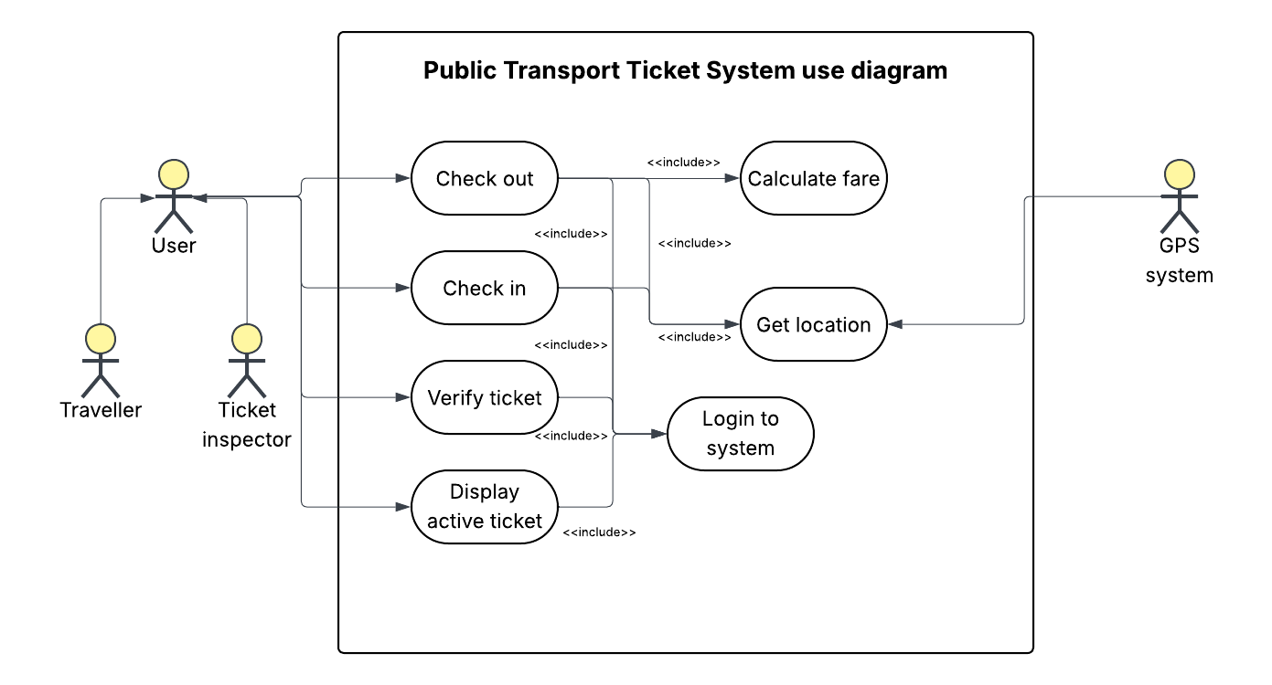
A diagram above shows how the Public Transport Ticket System works. User which can be Traveller or Ticket inspector is able to check out, check in, verify ticket or display active ticket. Those functions include logging to the system and allowing locations services so the GPS system can get the location of user. Checking out includes calculating a fare.

8. Class diagram

This section details the static architectural structure of the Public Transport Tickets System using a UML Class Diagram. It defines the core entities (classes) required to build the software, such as users, tickets, and stops, along with their respective attributes and operations. Furthermore, it maps out the fundamental object-oriented relationships between these entities—including inheritance, composition, and associations—providing developers with a clear blueprint for the system's backend design and data management.
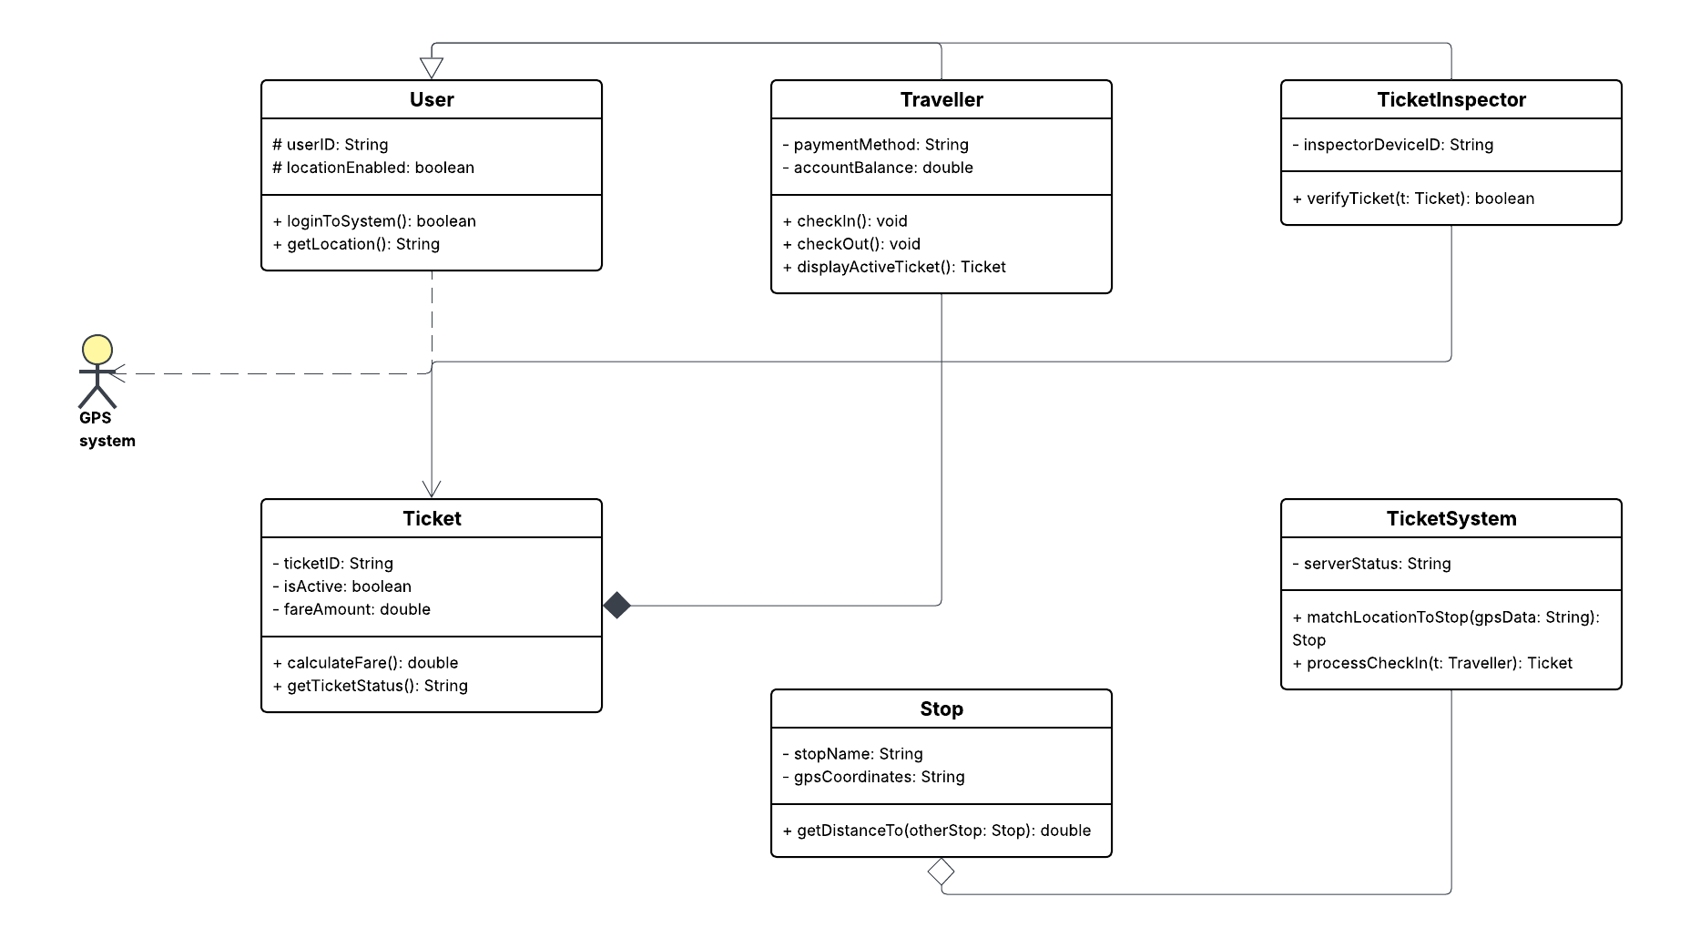

The class diagram for the Public Transport Tickets System outlines the structural foundation required to automate ticket purchasing and fare calculation. The architecture is built around several key entities and their relationships:
- User Hierarchy (Inheritance): At the core is the abstract User class, which handles general operations such as logging into the system. This class is inherited by two specific actors: the Traveller and the TicketInspector.

- Ticket Management (Composition & Association): The Traveller is responsible for initiating the Check in and Check out processes , which generate and manage a digital Ticket object. The TicketInspector has an association with the Ticket class to perform the Verify ticket operation.

- Location Tracking (Dependency & Aggregation): The system relies heavily on an external GPS System to fetch real-time location data. The main application controller aggregates these coordinates to identify the appropriate stops.

- Fare Processing: By utilizing the check-in and check-out data points, the system executes the Calculate farefunctionality dynamically at the end of the journey

9. Sequence / State /Activity Diagrams

The following sections present the behavioral models of the Public Transport Tickets System, shifting the focus from the static architecture to the dynamic execution of the software. This comprehensive behavioral view is captured through three key UML diagrams: a Sequence Diagram that details the chronological flow of messages between actors and internal system components; a State Diagram that illustrates the lifecycle and condition transitions of a user session during a journey; and an Activity Diagram that maps out the step-by-step operational logic of the core ticketing processes. Together, these diagrams provide developers and stakeholders with a clear, holistic blueprint of how the system operates, reacts to user inputs, and handles data in real-time.
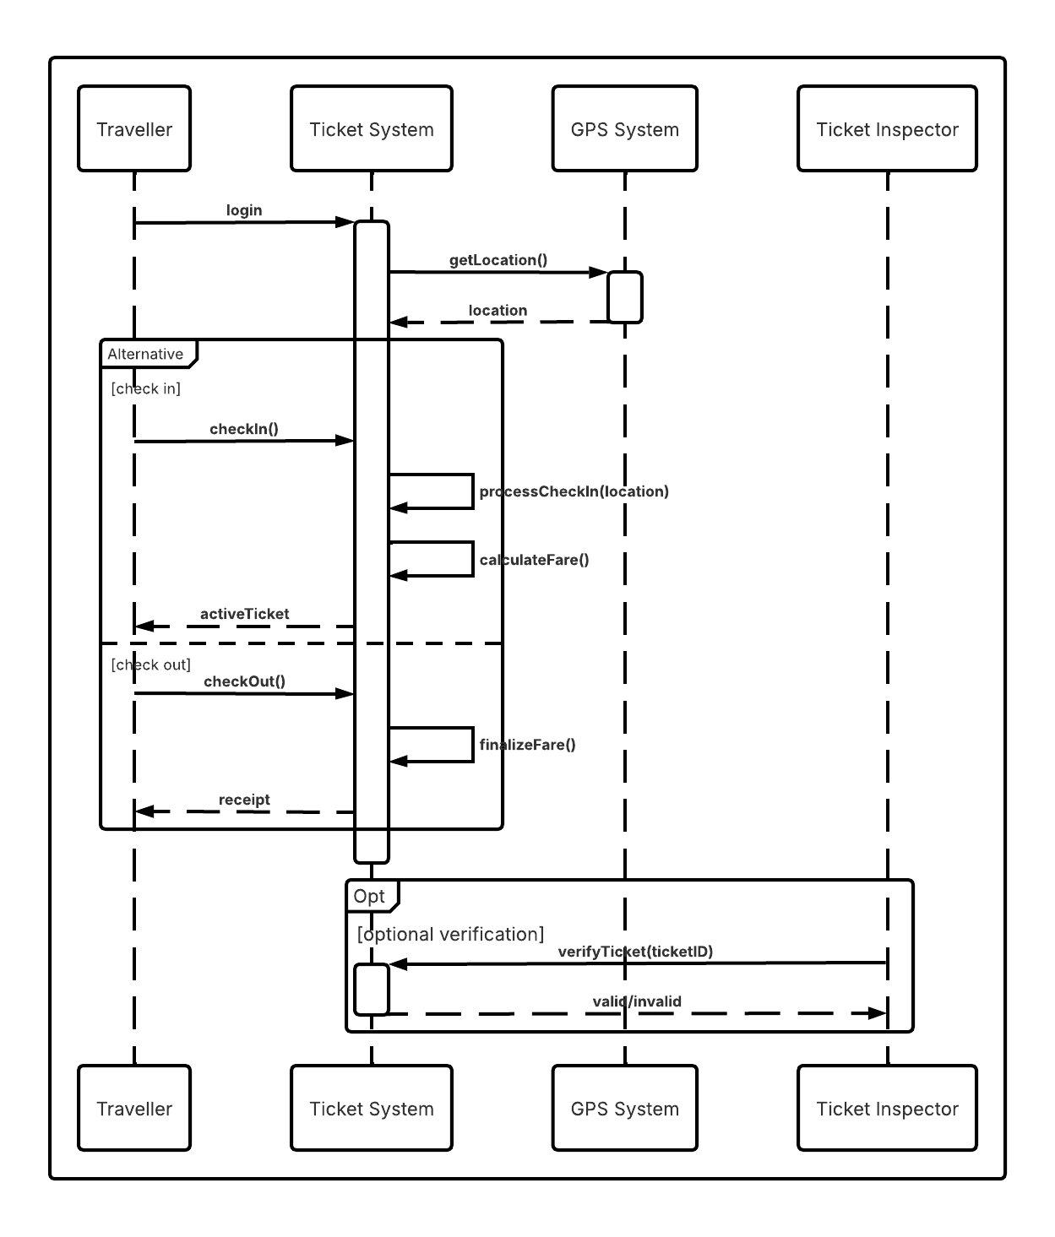
The sequence initiates with the Traveller logging into the system, which subsequently fetches the user's current coordinates from the GPS System. The core operations are encapsulated within an Alternative (Alt) frame, depicting two primary use cases:
- [check in]: The Traveller initiates the journey. The system processes the check-in data with the location, calculates the initial fare, and generates an activeTicket for the user.
- [check out]: The Traveller ends the journey. The system executes the finalizeFare() method and returns a receipt to the user.
Additionally, the diagram includes an Optional (Opt) frame at the end, representing a ticket control scenario. In this phase, a Ticket Inspector can independently send a verifyTicket(ticketID) request to the Ticket System to confirm whether the passenger's ticket is valid or invalid.

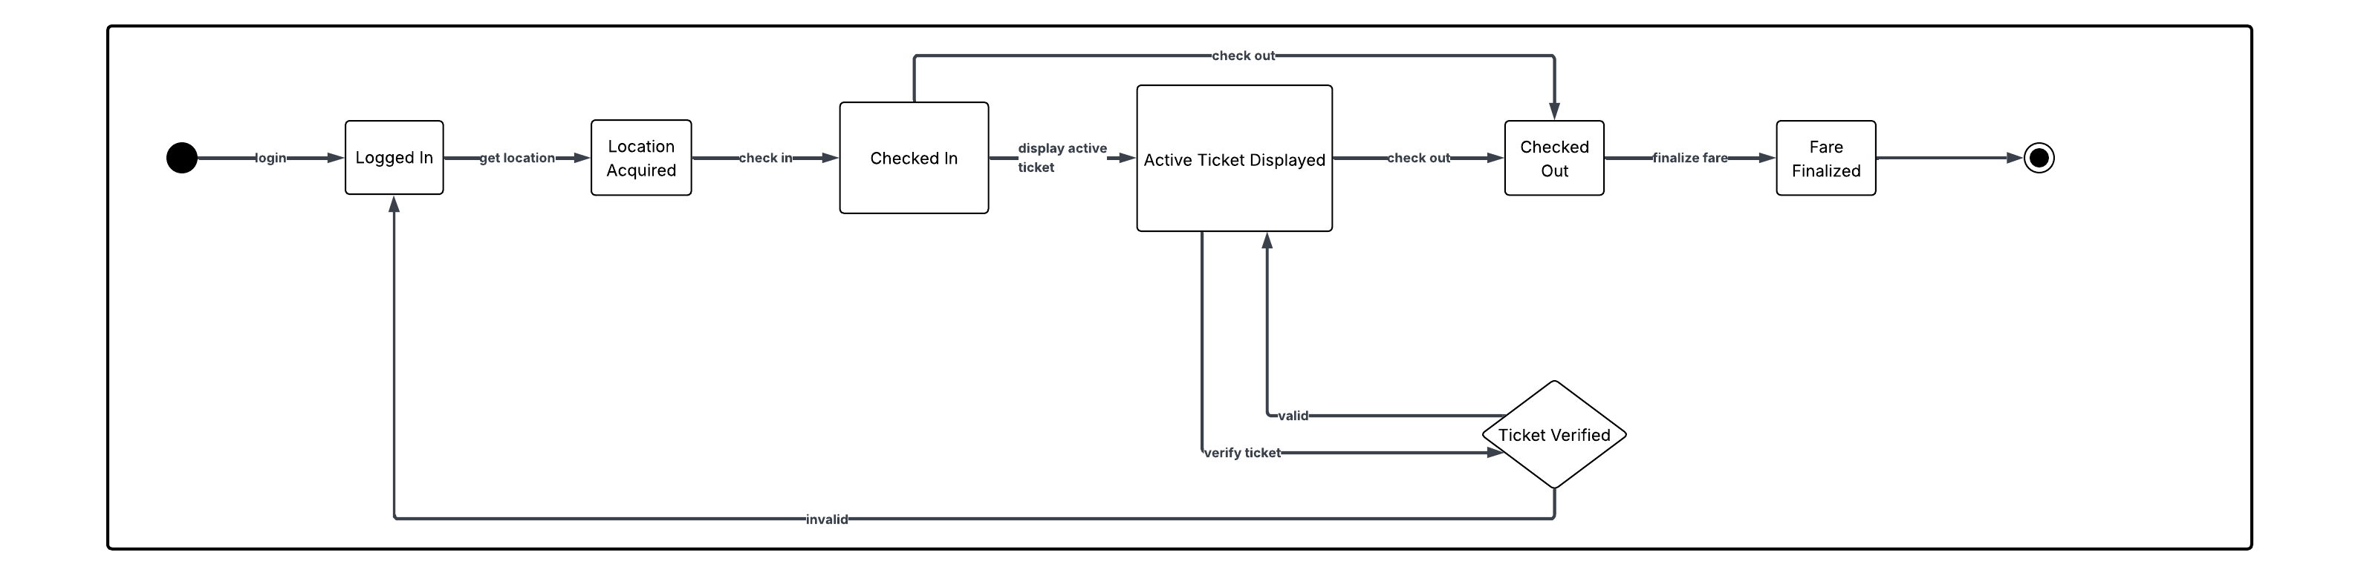
This state diagram illustrates the lifecycle of a user session and ticket status within the Public Transport Tickets System. The process begins when the user logs into the application, transitioning the system into the Logged In state. Once the GPS coordinates are retrieved (Location Acquired), the user can trigger a check-in.
During the journey, the system resides in the Checked In state. From here, the user can transition to the Active Ticket Displayedstate to show proof of payment. The diagram also accounts for ticket inspections: a verification trigger checks the ticket's validity. If the ticket is valid, the system returns to the active display; if invalid, the session reverts to the base Logged Instate. Ultimately, the user triggers a check-out, transitioning the system to the Checked Out state. The lifecycle concludes once the system processes the journey data and reaches the Fare Finalized state before termination.

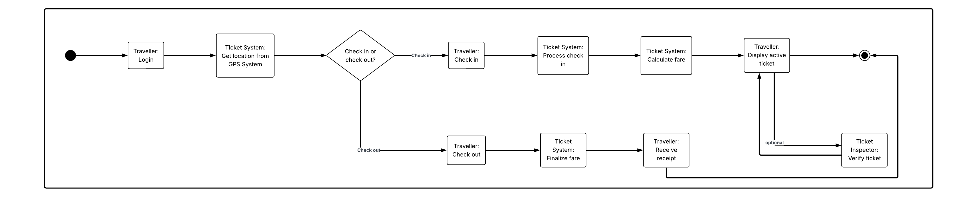

This activity diagram illustrates the operational flow of the Public Transport Tickets System. The process begins with the traveller logging into the application, immediately after which the system retrieves the current location from the GPS System. The flow then reaches a decision node representing the user's current action: checking in or checking out.
- Check-in pathway: If the user initiates a journey, the system processes the check-in, calculates the initial fare, and transitions to displaying the active ticket. This branch also accommodates an optional sub-flow where a Ticket Inspector can verify the ticket before the process concludes.

- Check-out pathway: If the user is ending their journey, the system executes the check-out process, finalizes the fare based on the traveled distance, and issues a receipt to the traveller.

10. Project Repository and Version Control
The source files, documentation, and UML models for this project are securely stored and managed using a Version Control System. Specifically, version control is tracked locally using Git , while the central repository is hosted online via GitHub to facilitate collaboration and backup.
The remote repository is named SE_Labs_Portfolio and acts as the comprehensive portfolio for the Software Engineering lab assignments.
The main workspace directory is structured under the Software-Engineering-Labs folder and contains the following strictly organized subfolders for the UML diagrams:
- /Lab1_Intro – Contains the initial version of the IEEE 830 Requirements Specification document and foundational project setup.
- /Lab2_UseCase_Diagrams – Contains the Use Case diagrams detailing system actors and functional interactions.
- /Lab3_Class_Diagrams – Contains the Class diagrams representing the static object-oriented structure of the systems.
- /Lab4_Behavioral_Diagrams – Contains the Sequence, State, and Activity diagrams modeling the dynamic behavior of the systems.
- /Lab5_Git – Contains the documentation regarding the implementation of the Git and GitHub workflow.

Repository Link: https://github.com/JakubTheProgrammer/SE_Labs_Portfolio.git

